Timothy Driscoll

ECE 6310

December 7, 2021

**Semester Project – Segmenting Foods**

**Introduction:**

The final project concerns the problem of building a graphical user interface and segmenting a variety of food images. A GUI was built to load images and implement a variety of active contouring techniques. These contouring techniques allowed for users to interact with the original images and contour specific areas of their choosing. There were three different active contouring methods implemented. The active contouring methods included a rubber band technique, balloon technique, and neutral technique that allows the user to make contour point adjustments. The final product was a user-friendly GUI application where the contouring could be performed.

**Functionality:**

The application functioned by loading in an image of the user’s choice and providing menu options for the different styles of contouring. A file was loaded in by using the File dropdown and selecting Load Image. The Quit option ends the GUI session.

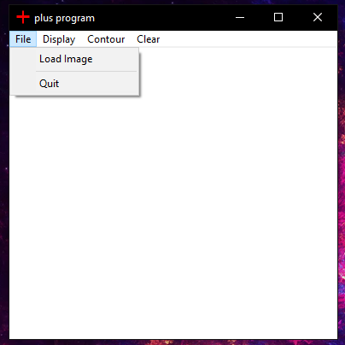

Figure 1. File dropdown menu options.

The second menu option allowed the user to select a variety of image display options. These options included Original Image, Sobel Image, and Clear Image. Both original image and clear image had similar effects of displaying the blank version of the image that the user initially loaded. Sobel Image displays the Sobel filtered version of the original image. This was primarily used internally by the program for contouring.

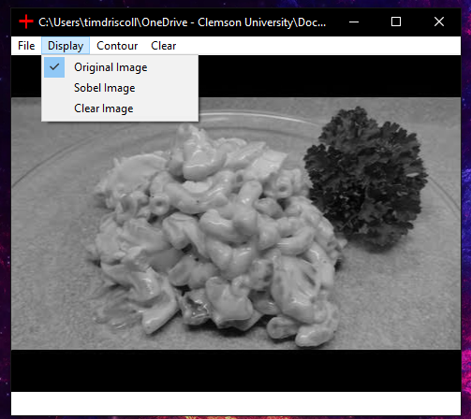

Figure 2. Display dropdown menu options.

The menu option “Contour” allowed the user to select from one of the three contouring models that were implemented in the program. The final menu option was used as a simple way to clear any contour points from the image.

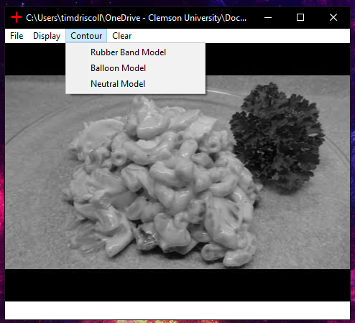

Figure 3. Contour dropdown menu options.

**Results:**

The results for this project will be displayed in a series of images. These images will be grouped by the contouring model that was implemented.

Rubber Band Model:

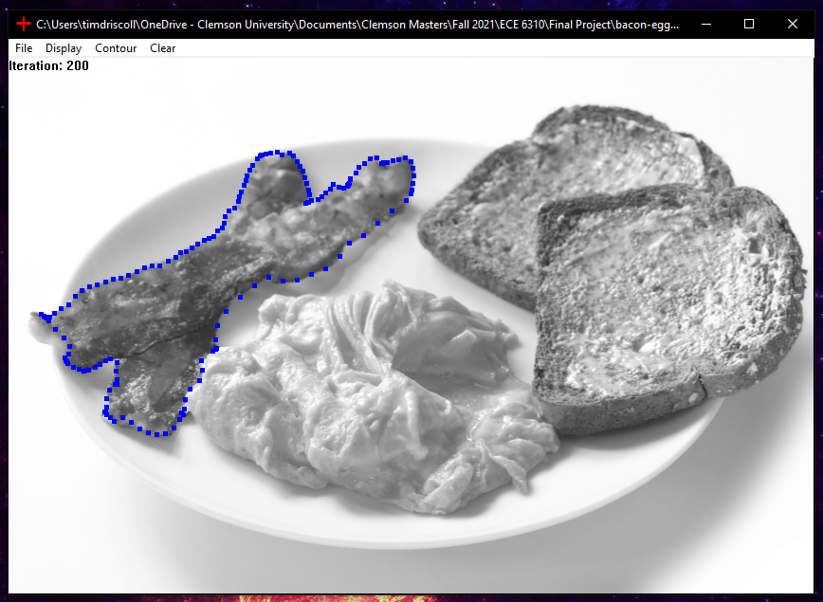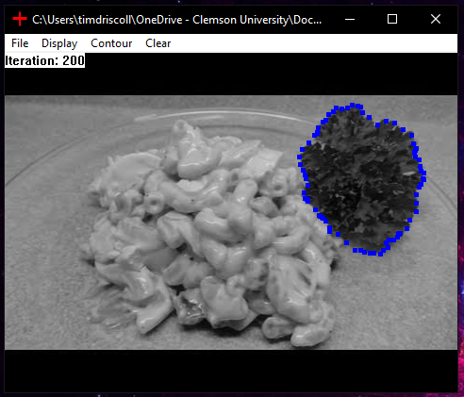

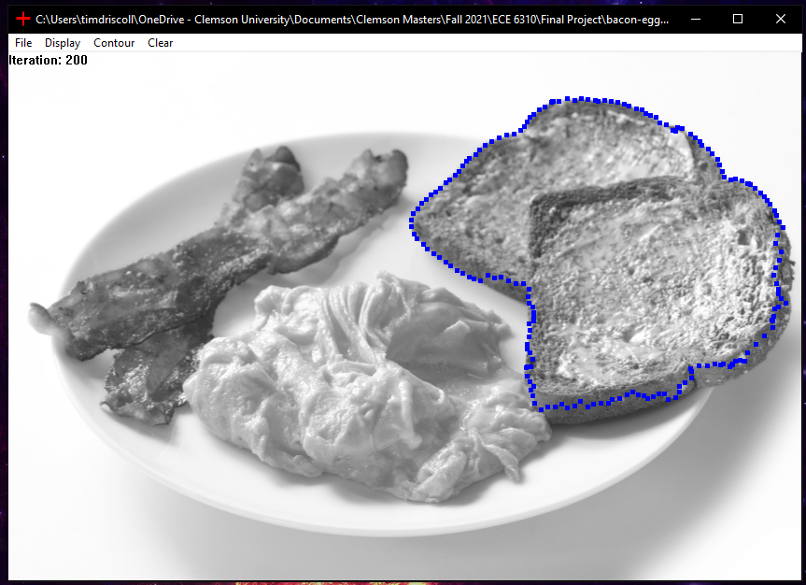

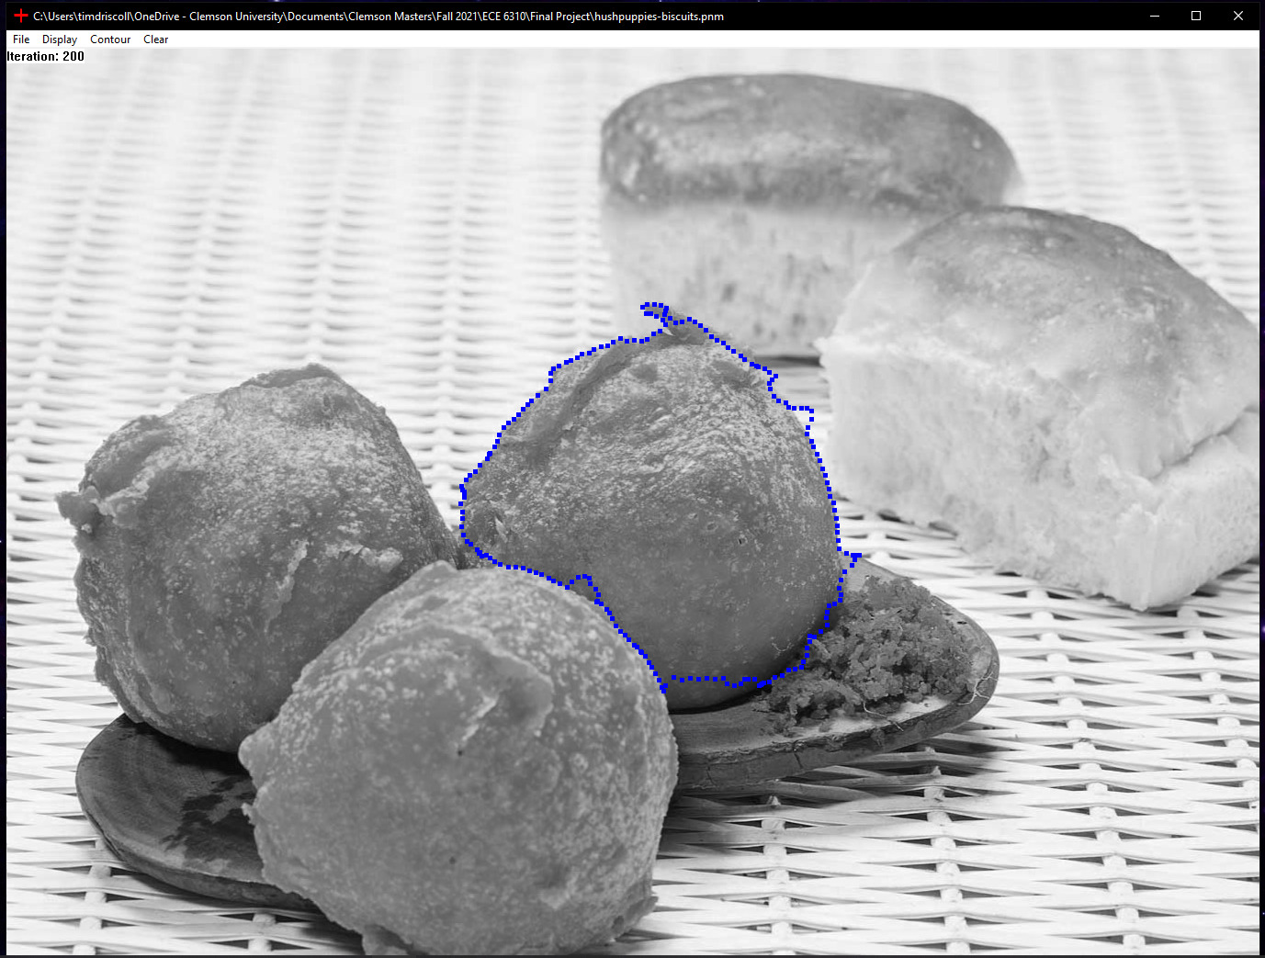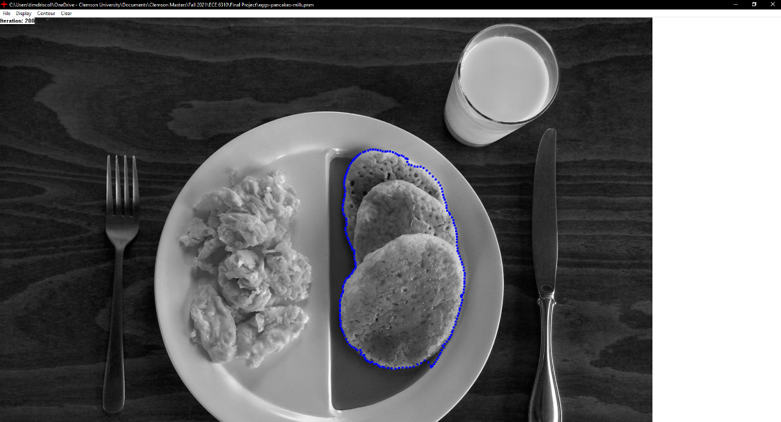

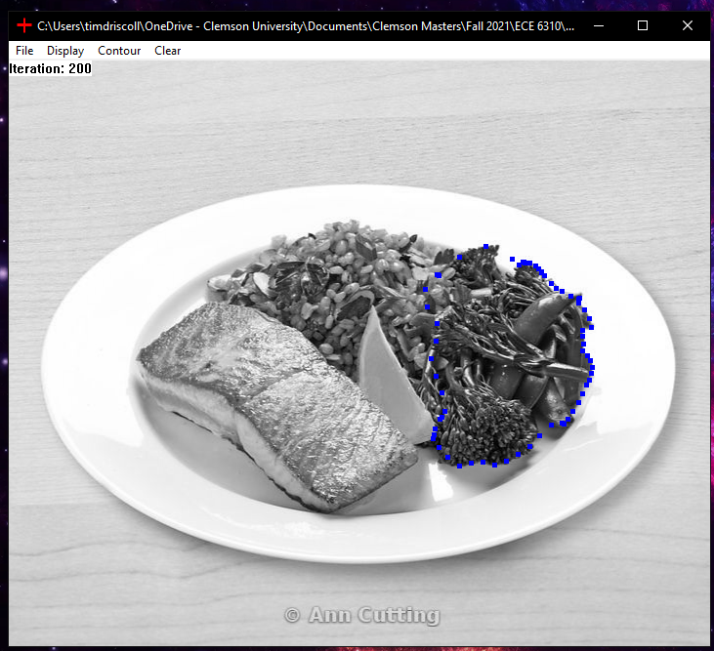



Balloon Model:

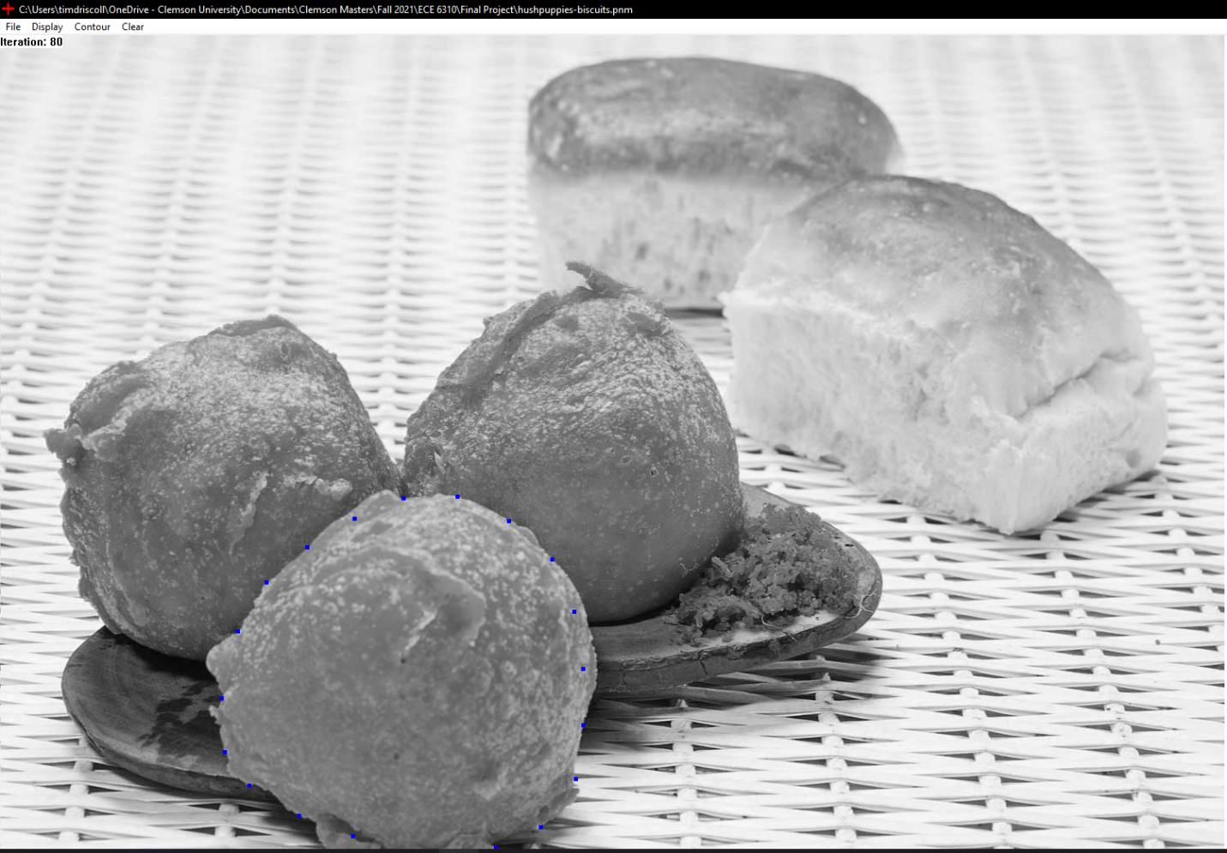

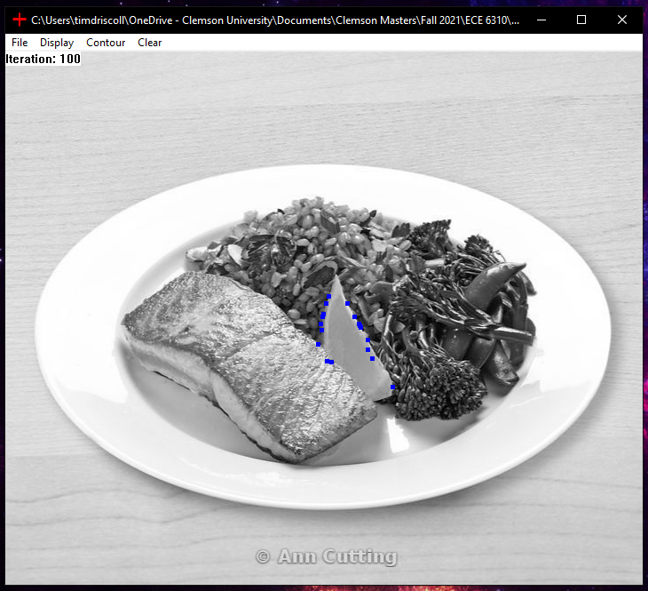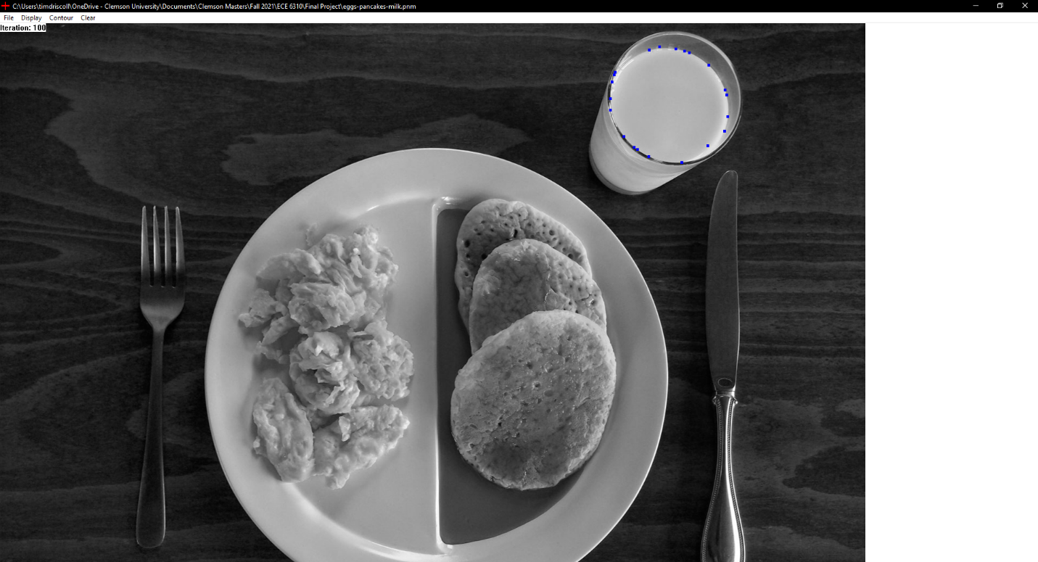

Neutral Model:

For the neutral model, either the rubber band or balloon model must be initially be used. The user then can select the neutral contour model. After the user selects this model, they can hold the shift key a left mouse button to move the location of any contour point. After the point is moved it will be highlighted light blue and the neutral contour algorithm will begin. The light blue point is fixed at the location it was moved two. The first image shows an issue where the rubber band contour didn’t snap to the pancake on the right side. This was fixed using the neutral model by anchoring the light blue point in the second image.

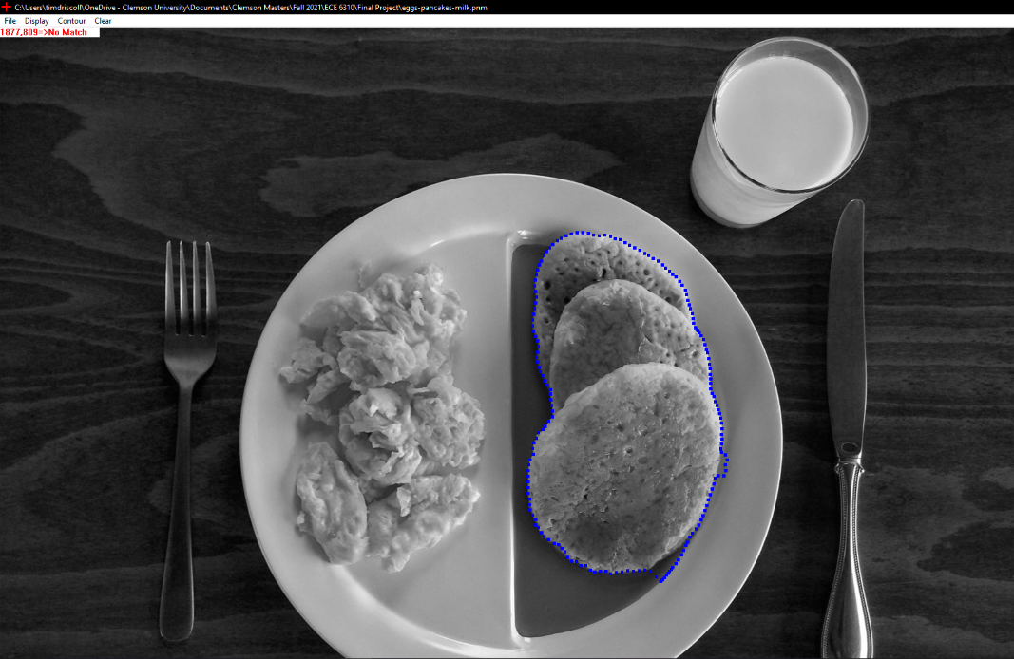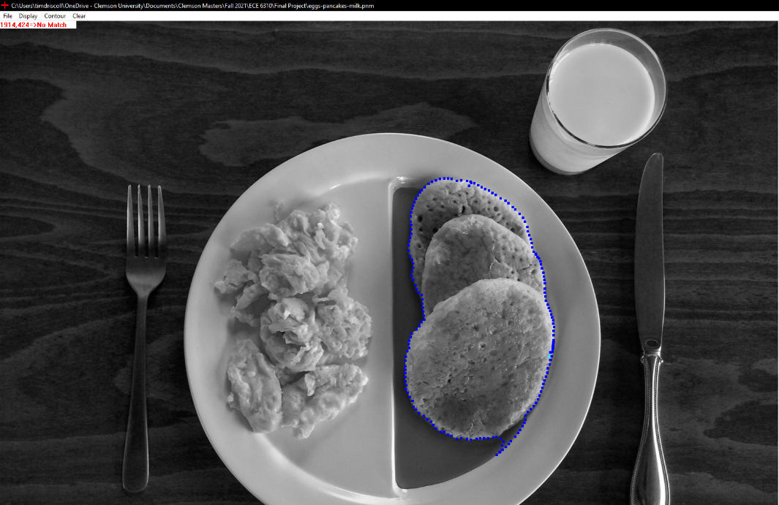

**Conclusion:**

Overall, the GUI produced for this project successfully implemented all the desired functionality. The user was able to load in different images and use a variety of different contouring methods to segment the food. All the contouring methods properly worked but were more successful on some images than others. Specifically, the rubber band contour performed well on most of the images, but the balloon method only functioned well in certain cases. The neutral method was effective at helping to make small contouring adjustments but failed in areas where the initial contour poorly fit the food that was being segmented. This shows the importance of using a variety of energy terms and tuning the weights to certain cases.